**NORMALISATION**

TABLES BEFORE NORMALISATION:

1) ADMINISTRATOR (Emp_id, Emp_firstName, Emp_lastName, Emp_Gender, Emp_DOB, Emp_Designation, Hired_date, Emp_workingStatus)

2) CUSTOMER (Customer_id, AccountID, Customer_firstName, Customer_lastName, Customer_Gender, DOB, State, City, Customer_Address, Zip_code, Email_Id, Mobile_no1, Mobile_no2, UserLoginID)

3) ACCOUNT-DETAILS(AccountID, CurrentBalance, AccountType, AccountStatus, SavingsInterestRate)

4) REGISTRATION(RegisterID, UserName, UserLoginID, Password, Email_Id, Mobile_no1)

5) LOGIN-ACCOUNT(UserLoginID, AccountID)

6) USERLOGINS (UserLoginID, UserName, Password)

7) SecurityAnswers (UserLoginID, Security_Ans, Security_QuestID)

8) SecurityQuestions (Security_QuestID, Security_Questions)

9) TRANSACTION (TransactionID, TransactionDate, TransactionTime, TransactionType, TransactionAmount, NewBalance, AccountID, Customer_id, UserLoginID, WithdrawalCount, DepositCount)

10) LOAN-DETAILS (LoanNumber, AccountID, LoanAmount, InterestRate, LoanApprovalDate)

11) CARD-DETAILS (AccountID, CardHolder, CardType, CCV, ExpirtDate)

12) BILL-PAYMENTS (BillPayment_no, PaymentType, PaymentConfirmation, PaymentAmount, Customer_id)

13) FailedTransactionLog (FailedTransaction_errorType, FailedTransactionID)

MASTER SCHEMA:

BANK(Emp_id, Emp_firstName, Emp_lastName, Emp_Gender, Emp_DOB, Emp_Designation, Hired_date, Emp_workingStatus, Emp_Mobile, Customer_id, AccountID, Customer_firstName, Customer_lastName, Customer_Gender, DOB, State, City, Customer_Address, Zip_code, Email_Id, Mobile_no, UserLoginID, AccountID, CurrentBalance, AccountType, AccountStatus, SavingsInterestRate, RegisterID, UserName, Password, Security_Ans, Security_QuestID, Security_Questions, TransactionID, TransactionDate, TransactionTime, TransactionType, TransactionAmount, NewBalance, WithdrawalCount, DepositCount, LoanNumber, LoanAmount, InterestRate, LoanApprovalDate, CardHolder, CardType, CCV, ExpirtDate, BillPayment_no, PaymentType, PaymentConfirmation, PaymentAmount, FailedTransaction_errorType, FailedTransactionID)

1 NF:

Multivariable attributes: TransactionID, Mobile_no, Emp_Mobile, LoanNumber, BillPayment_no.

Table 1:

BANK(Emp_id, Emp_firstName, Emp_lastName, Emp_Gender, Emp_DOB, Emp_Designation, Hired_date, Emp_workingStatus, Customer_id, AccountID, Customer_firstName, Customer_lastName, Customer_Gender, DOB, State, City, Customer_Address, Zip_code, Email_Id, UserLoginID, AccountID, CurrentBalance, AccountType, AccountStatus, SavingsInterestRate, RegisterID, UserName, Password, Security_Ans, Security_QuestID, Security_Questions, TransactionID, TransactionDate, TransactionTime, TransactionType, TransactionAmount, NewBalance, WithdrawalCount, DepositCount, LoanNumber, LoanAmount, InterestRate, LoanApprovalDate, CardHolder, CardType, CCV, ExpirtDate, BillPayment_no, PaymentType, PaymentConfirmation, PaymentAmount, FailedTransaction_errorType, FailedTransactionID)

Table 2:

Cus_Mobile (Customer_id, Mobile_no)

Table 3:

Emp_Mob(Emp_id, Emp_Mobile)

Table 4:

Loan_num(Customer_id, LoanNumber)

Table 5:

Transact (AccountID, TransactionID)

Table 6:

Bill (AccountID, Bill_payment_no)

2 NF:

Master Schema is decomposed and all the partial dependencies are identified,

1) ADMINISTRATOR (Emp_id, Emp_firstName, Emp_lastName, Emp_Gender, Emp_DOB, Emp_Designation, Hired_date, Emp_workingStatus)

Functional Dependencies:

(Emp_id) 🡪 (Emp_firstName, Emp_lastName, Emp_Gender, Emp_DOB, Emp_Designation, Emp_workingStatus, Hired_date)

2) CUSTOMER (Customer_id, AccountID, UserLoginID, Customer_firstName, Customer_lastName, Customer_Gender, DOB, State, City, Customer_Address,

Zip_code, Email_Id, Mobile_no)

Functional Dependencies:

(Customer_id) 🡪 (AccountID, UserLoginID, Customer_firstName, Customer_lastName, Customer_Gender, DOB, State, City, Customer_Address, Zip_code, Email_Id)

3) ACCOUNT-DETAILS(AccountID, CurrentBalance, AccountType, AccountStatus, SavingsInterestRate)

Functional Dependencies:

(AccountID) 🡪 (CurrentBalance, AccountType, AccountStatus, SavingsInterestRate)

4) REGISTRATION(RegisterID, UserName, UserLoginID, Password, Email_Id, Mobile)

Functional Dependencies:

(RegisterID, UserLoginID) 🡪 (UserName, Password, Email_Id, Mobile)

5) TRANSACTION (TransactionID, TransactionDate, TransactionTime, TransactionType, TransactionAmount, NewBalance, WithdrawalCount, DepositCount)

Functional Dependencies:

(TransactionID) 🡪 (TransactionDate, TransactionTime, TransactionType, TransactionAmount, NewBalance, WithdrawalCount, DepositCount)

6) LOAN-DETAILS (LoanNumber, LoanAmount, InterestRate, LoanApprovalDate, LoanType)

Functional Dependencies:

(LoanNumber) 🡪 (LoanAmount, InterestRate, LoanApprovalDate, LoanType)

7) CARD-DETAILS (CardNumber, CardHolder, CardType, CCV, ExpirtDate)

Functional Dependencies:

(CardNumber) 🡪 (CardHolder, CardType, CCV, ExpirtDate)

8) BILL-PAYMENTS (BillPayment_no, PaymentType, PaymentConfirmation, PaymentAmount)

Functional Dependencies:

(BillPayment_no) 🡪 (PaymentType, PaymentConfirmation, PaymentAmount)

9) FailedTransactionLog (FailedTransaction_errorType, FailedTransactionID)

Functional Dependencies:

(FailedTransactionID) 🡪 (FailedTransaction_errorType)

10) USERLOGINS (UserLoginID, UserName, Password)

Functional Dependencies:

(UserLoginID) 🡪 (Username, Password)

PARTIAL DEPENDENCY:

11a) Security_Anss (UserLoginID, Security_QuestID, Security_Ans)

Functional Dependencies:

(UserLoginID, Security_QuestID) 🡪 (Security_Ans)

11b) Security_Quest (Security_QuestID, Security_Questions)

Functional Dependencies:

(Security_QuestID) 🡪 (Security_Questions)

3 NF:

Further the decomposed master schema should be segregated on the basis of transitive dependency.

1) ADMINISTRATOR (Emp_id, Emp_firstName, Emp_lastName, Emp_Gender, Emp_DOB, Emp_Designation, Hired_date, Emp_workingStatus)

Functional Dependencies:

(Emp_id) 🡪 (Emp_firstName, Emp_lastName, Emp_Gender, Emp_DOB, Emp_Designation, Emp_workingStatus, Hired_date)

2) ACCOUNT-DETAILS(AccountID, CurrentBalance, AccountType, AccountStatus, SavingsInterestRate)

Functional Dependencies:

(AccountID) 🡪 (CurrentBalance, AccountType, AccountStatus, SavingsInterestRate)

3) REGISTRATION(RegisterID, UserName, UserLoginID, Password, Email_Id, Mobile)

Functional Dependencies:

(RegisterID, UserLoginID) 🡪 (UserName, Password, Email_Id, Mobile)

4) Security_Anss (UserLoginID, Security_QuestID, Security_Ans)

Functional Dependencies:

(UserLoginID, Security_QuestID) 🡪 (Security_Ans)

5) Security_Quest (Security_QuestID, Security_Questions)

Functional Dependencies:

(Security_QuestID) 🡪 (Security_Questions)

6) TRANSACTION (TransactionID, TransactionDate, TransactionTime, TransactionType, TransactionAmount, NewBalance, WithdrawalCount, DepositCount, OldBalance)

Functional Dependencies:

(TransactionID) 🡪 (TransactionDate, TransactionTime, TransactionType, TransactionAmount, NewBalance, WithdrawalCount, DepositCount, OldBalance)

7) CARD-DETAILS (CardNumber, CardHolder, CardType, CCV, ExpirtDate)

Functional Dependencies:

(CardNumber) 🡪 (CardHolder, CardType, CCV, ExpirtDate)

8) BILL-PAYMENTS (BillPayment_no, PaymentType, PaymentConfirmation, PaymentAmount)

Functional Dependencies:

(BillPayment_no) 🡪 (PaymentType, PaymentConfirmation, PaymentAmount)

9) FailedTransactionLog (FailedTransaction_errorType, FailedTransactionID)

Functional Dependencies:

(FailedTransactionID) 🡪 (FailedTransaction_errorType)

10) USERLOGINS (UserLoginID, UserName, password)

TRANSITIVE DEPENDENCY:

11a) LOANTYPE (Loan_Type, InterestRate)

Functional Dependencies:

(Loan_Type) 🡪 (InterestRate)

11b) LOAN-DETAILS (LoanNumber, LoanAmount, LoanApprovalDate, LoanType)

Functional Dependencies:

(LoanNumber) 🡪 (LoanAmount, LoanApprovalDate, LoanType)

12a) CUSTOMER (Customer_id, AccountID, UserLoginID, Customer_firstName, Customer_lastName, Customer_Gender, DOB, Customer_Address, Email_Id, Mobile_no)

Functional Dependencies:

(Customer_id) 🡪 (AccountID, UserLoginID, Customer_firstName, Customer_lastName, Customer_Gender, DOB, Customer_Address, Email_Id, Zip_code)

12b) State_city(City,State)

Functional Dependencies:

(City) 🡪 (State)

12c) Zip (Zip_code, City)

Functional Dependencies:

(Zip_code) 🡪 (City)

BCNF:

All the tables are in BCNF.

FINALIZED TABLES:

1) ADMINISTRATOR (Emp_id, Emp_firstName, Emp_lastName, Emp_Gender, Emp_DOB, Emp_Designation, Hired_date, Emp_workingStatus)

2) CUSTOMER (Customer_id, AccountID, UserLoginID, Customer_firstName, Customer_lastName, Customer_Gender, DOB, Customer_Address,

Zip_code, Email_Id, Mobile_no)

3) ACCOUNT_DETAILS(AccountID, CurrentBalance, AccountType, AccountStatus, SavingsInterestRate)

4) REGISTRATION(RegisterID, UserName, UserLoginID, Password, Email_Id, Mobile)

5) SECURITY_ANSS (UserLoginID, Security_QuestID, Security_Ans)

6) SECURITY_QUEST (Security_QuestID, Security_Questions)

7) TRANSACTION (TransactionID, TransactionDate, TransactionTime, TransactionType, TransactionAmount, NewBalance, WithdrawalCount, DepositCount, OldBalance)

8) State_city (City, State)

9) Zip (Zip_code, City)

10) LOANTYPE (Loan_Type, InterestRate)

11) LOAN_DETAILS (LoanNumber, LoanAmount, LoanApprovalDate, LoanType)

12) CARD_DETAILS (CardNumber, CardHolder, CardType, CCV, ExpirtDate)

13) BILL_PAYMENTS (BillPayment_no, PaymentType,PaymentConfirmation,

PaymentAmount)

14) FailedTransactionLog (FailedTransaction_errorType, FailedTransactionID)

15) USERLOGINS (UserLoginID, UserName, password)

16) Cus_Mobile (Customer_id, Mobile_no)

17) Emp_Mob (Emp_id, Emp_Mobile)

18) Loan_num (Customer_id, LoanNumber)

19) Transact (AccountID, TransactionID)

20) Bill (AccountID, Bill_payment_no)

CREATION OF TABLES AND INSERTION OF RECORDS:

TABLE 1:

Create TABLE ADMINISTRATOR (Emp_id varchar (10) PRIMARY KEY, Emp_firstName varchar (30), Emp_lastName varchar (30), Emp_Gender char (1), Emp_DOB date, Emp_Designation varchar2(20), Hired_date date, Emp_workingStatus varchar2(20));

Insert into ADMINISTRATOR values ('AMAR0001','AMAR','S','M',

date '1987-09-21','Manager', date '2015-08-09','Employeed');

Insert into ADMINISTRATOR values ('SARA0002','SARA','PAL','F', date'1995-05-01','Assistant', date '2021-06-20','Employeed');

Insert into ADMINISTRATOR values ('AMAL0004','AMALA','FAZIL','F', date '1988-09-26','Cashier', date '2020-08-29','Employeed');

Insert into ADMINISTRATOR values ('MICH0005','MICHAEL','B','M', date '1999-11-01','Credit Analyst', date '2018-02-15','Employeed');

Insert into ADMINISTRATOR values ('DANI0007','DANIEL','PAUL','M', date '1989-02-28','Credit Analyst', date '2017-09-03','Employeed');

Insert into ADMINISTRATOR values ('JOSH0003','JOSHUA','RAJ','M', date '1995-10-11','Loan Processor', date '2017-01-04','Employeed');

Insert into ADMINISTRATOR values ('BETT0009','BETTY','COOPER','F', date '1995-05-05','Assistant', date '2017-09-07','Employeed');

Insert into ADMINISTRATOR values ('SHAR0011','SHARON','BIANCA','F', date '1987-08-18','Financial Analyst', date '2019-04-19','Employeed');

Insert into ADMINISTRATOR values ('EMIL0015','EMILA','CLARKE','F', date '1991-08-29','Auditor', date '2019-03-12','Resigned');

Insert into ADMINISTRATOR values ('RYAN0010','RYAN','GARY','M', date '1996-07-01','Auditor', date '2020-01-13','Employeed');

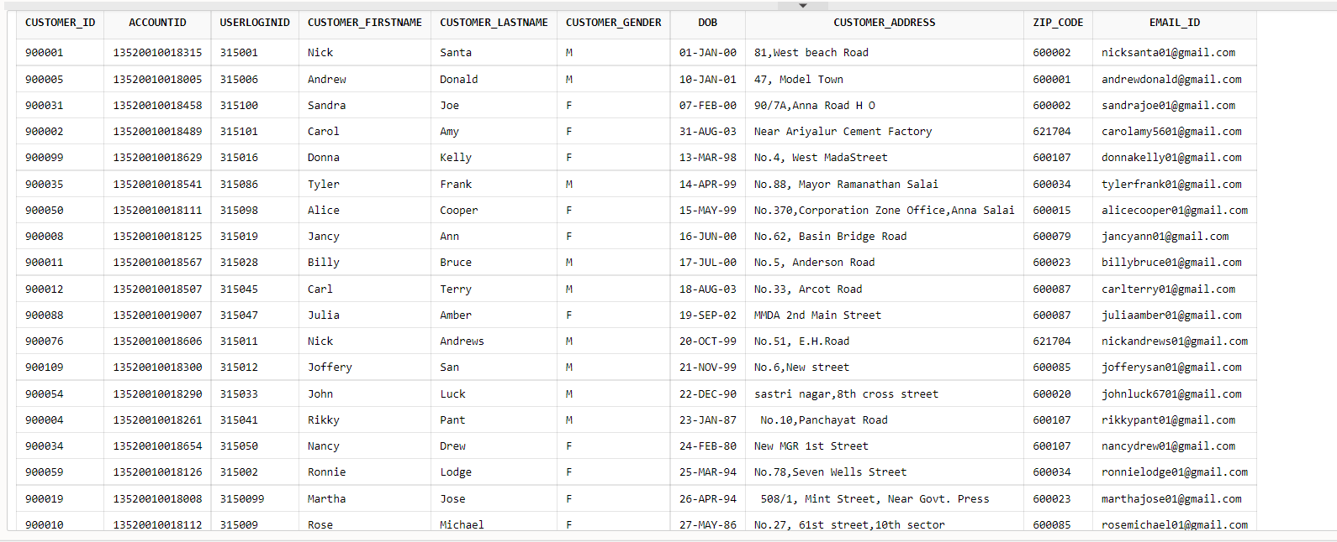

TABLE 2:

Create Table CUSTOMER (Customer_id int PRIMARY KEY, AccountID varchar (20), UserLoginID int, Customer_firstName varchar (30), Customer_lastName varchar (30), Customer_Gender char (1), DOB date

, Customer_Address varchar2(100), Zip_code int, Email_Id varchar (30));

Insert into CUSTOMER values (900001,'13520010018315',315001,'Nick','Santa','M', date '2000-01-01','81, West beach Road',625543, 'nicksanta01@gmail.com');

Insert into CUSTOMER values (900005,'13520010018005',315006,'Andrew','Donald','M', date '2001-01-10','47, Model Town',600001, 'andrewdonald@gmail.com');

Insert into CUSTOMER values (900023,'13520010018888',315049,'Eric','C','M', date '2001-11-21','A/2, Bunder Road, Sewri (east)', 600001, 'ericc00901@gmail.com');

Insert into CUSTOMER values (900031,'13520010018458',315100,'Sandra','Joe','F', date '2000-02-07','90/7A, Anna Road H O',600002, 'sandrajoe01@gmail.com');

Insert into CUSTOMER values (900002,'13520010018489',315101,'Carol','Amy','F', date '2003-08-31','Near Ariyalur Cement Factory',621704,'carolamy5601@gmail.com');

Insert into CUSTOMER values(900099,'13520010018629',315016,'Donna','Kelly','F',date '1998-03-13','No.4, West MadaStreet',600107,'donnakelly01@gmail.com');

Insert into CUSTOMER values(900035,'13520010018541',315086,'Tyler','Frank','M',date '1999-04-14','No.88, Mayor Ramanathan Salai',600034,'tylerfrank01@gmail.com');

Insert into CUSTOMER values(900050,'13520010018111',315098,'Alice','Cooper','F',date '1999-05-15','No.370,Corporation Zone Office,Anna Salai',600015,'alicecooper01@gmail.com');

Insert into CUSTOMER values(900008,'13520010018125',315019,'Jancy','Ann','F',date '2000-06-16','No.62, Basin Bridge Road', 600079,'jancyann01@gmail.com');

Insert into CUSTOMER values(900011,'13520010018567',315028,'Billy','Bruce','M',date '2000-07-17','No.5, Anderson Road',600023,'billybruce01@gmail.com');

Insert into CUSTOMER values(900012,'13520010018507',315045,'Carl','Terry','M',date '2003-08-18','No.33, Arcot Road',600087,'carlterry01@gmail.com');

Insert into CUSTOMER values(900088,'13520010019007',315047,'Julia','Amber','F',date '2002-09-19','MMDA 2nd Main Street',600087,'juliaamber01@gmail.com');

Insert into CUSTOMER values(900076,'13520010018606',315011,'Nick','Andrews','M',date '1999-10-20','No.51, E.H.Road',621704,'nickandrews01@gmail.com');

Insert into CUSTOMER values(900109,'13520010018300',315012,'Joffery','San','M',date '1999-11-21','No.6,New street',600085,'jofferysan01@gmail.com');

Insert into CUSTOMER values(900054,'13520010018290',315033,'John','Luck','M',date '1990-12-22','sastri nagar,8th cross street',600020,'johnluck6701@gmail.com');

Insert into CUSTOMER values(900004,'13520010018261',315041,'Rikky','Pant','M',date '1987-01-23',' No.10,Panchayat Road',600107,'rikkypant01@gmail.com');

Insert into CUSTOMER values(900034,'13520010018654',315050,'Nancy','Drew','F',date '1980-02-24','New MGR 1st Street',600107,'nancydrew01@gmail.com');

Insert into CUSTOMER values(900059,'13520010018126',315002,'Ronnie','Lodge','F',date '1994-03-25','No.78,Seven Wells Street',600034,'ronnielodge01@gmail.com');

Insert into CUSTOMER values(900019,'13520010018008',315099,'Martha','Jose','F',date '1994-04-26',' 508/1, Mint Street, Near Govt. Press',600023,'marthajose01@gmail.com');

Insert into CUSTOMER values(900010,'13520010018112',315009,'Rose','Michael','F',date '1986-05-27','No.27, 61st street,10th sector',600085,'rosemichael01@gmail.com');

--select * from CUSTOMER;

--drop table CUSTOMER;

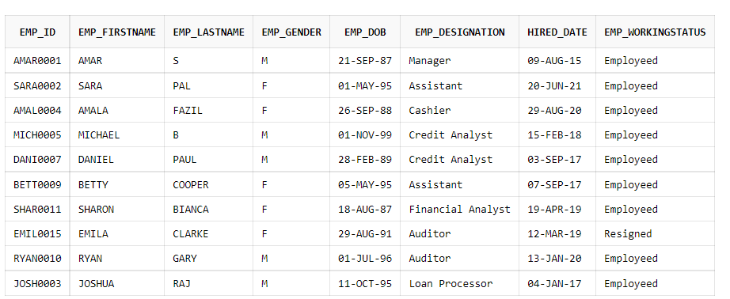

TABLE 3:

Create Table ACCOUNT_DETAILS (AccountID varchar(20) PRIMARY KEY, CurrentBalance float, AccountType varchar2(20), AccountStatus varchar2(20), SavingsInterestRate float);

Insert into ACCOUNT_DETAILS values('13520010018315',3500.0,'Savings','Current',3.5);

Insert into ACCOUNT_DETAILS values('13520010018888',48000.0,'Salary','Current',4.0);

Insert into ACCOUNT_DETAILS values('13520010018005',33490.0,'Savings','Inactive',0);

Insert into ACCOUNT_DETAILS values('13520010018458',35209.0,'Savings','Current',3.5);

Insert into ACCOUNT_DETAILS values('13520010018111',350.0,'Savings','Current',3.5);

Insert into ACCOUNT_DETAILS values('13520010018567',2098.0,'Savings','Current',3.5);

Insert into ACCOUNT_DETAILS values('13520010018507',10089.0,'Salary','Current',4.0);

Insert into ACCOUNT_DETAILS values('13520010018606',1008.0,'Salary','Current',4.0);

Insert into ACCOUNT_DETAILS values('13520010019007',90065.0,'Savings','Current',3.5);

Insert into ACCOUNT_DETAILS values('13520010018489',900.0,'Salary','Current',4.0);

Insert into ACCOUNT_DETAILS values('13520010018629',1098.80,'Savings','Current',3.5);

Insert into ACCOUNT_DETAILS values('13520010018541',5768.30,'FD','Current',3.9);

Insert into ACCOUNT_DETAILS values('13520010018125',2747.90,'Savings','Current',3.5);

Insert into ACCOUNT_DETAILS values('13520010018300',12893.0,'FD','Inactive',0);

Insert into ACCOUNT_DETAILS values('13520010018654',87872.0,'Salary','Current',4.0);

Insert into ACCOUNT_DETAILS values('13520010018290',890.0,'Salary','Current',4.0);

Insert into ACCOUNT_DETAILS values('13520010018112',4777.0,'FD','Current',3.9);

Insert into ACCOUNT_DETAILS values('13520010018008',9989.0,'Savings','Current',3.5);

Insert into ACCOUNT_DETAILS values('13520010018126',99978.0,'Savings','Current',3.5);

Insert into ACCOUNT_DETAILS values('13520010018261',8988.34,'Salary','Current',4.0);

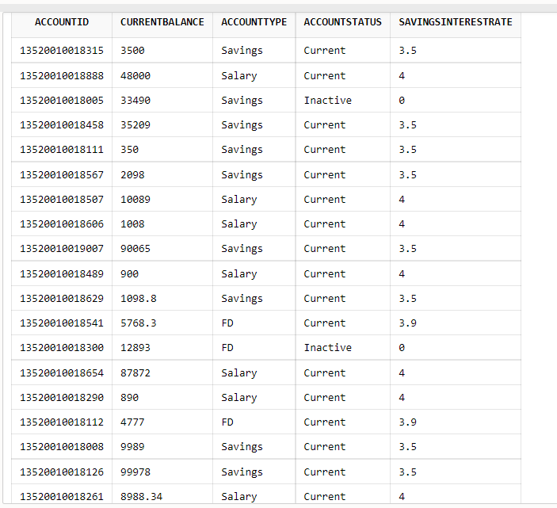

TABLE 4:

Create table REGISTRATION (RegisterID int PRIMARY KEY, UserName varchar(20), UserLoginID int, Password varchar(12), Email_Id varchar(30), Mobile_no1 number(10));

Insert into REGISTRATION values(250001,'NickSanta',315001,'abcdefghijkl','nicksanta01@gmail.com',9087685649);

Insert into REGISTRATION values(250002,'CarolAmy',315101,'mskxhdnzjsnd','carolamy5601@gmail.com',8084383948);

Insert into REGISTRATION values(250003,'DonnaKelly',315016,'abcdebkzdnkx','donnakelly01@gmail.com',9902746392);

Insert into REGISTRATION values(250004,'JuliaAmber',315047,'abdkecxjfbd','juliaamber01@gmail.com',9027492678);

Insert into REGISTRATION values(250005,'BillyBruce',315028,'iskfjddkzuql','nicksanta01@gmail.com',8818384927);

Insert into REGISTRATION values(250006,'TylerFrank',315086,'weguyqoitjkl','billybruce01@gmail.com',9018375026);

Insert into REGISTRATION values(250007,'AliceCooper',315098,'aaypletcuirl','alicecooper01@gmail.com',7189356792);

Insert into REGISTRATION values(250008,'NickAndrews',315011,'auielodtyupl','nickandrews01@gmail.com',7284509267);

Insert into REGISTRATION values(250009,'CarlTerry',315045,'abcdaiporylo','carlterry01@gmail.com',8820947389);

Insert into REGISTRATION values(250010,'MarthaJose',315099,'ndpoeyuprnzl','marthajose01@gmail.com',9289383900);

Insert into REGISTRATION values(250011,'RonnieLodge',315002,'bamkywkoeudj','ronnielodge01@gmail.com',8209340923);

Insert into REGISTRATION values(250012,'JofferySan',315012,'pwormxtjsilk','jofferysan01@gmail.com',9092830234);

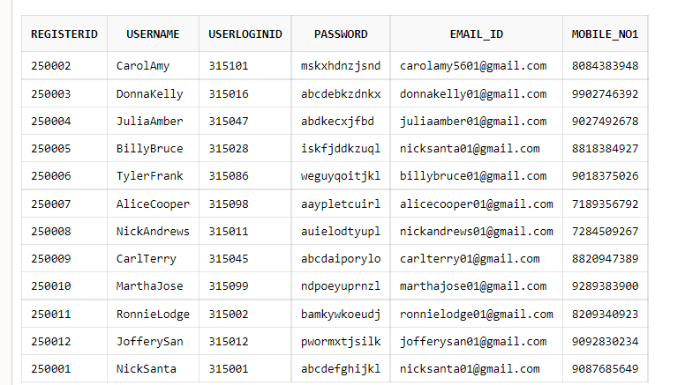

TABLE 5:

Create Table SECURITY_ANSS (UserLoginID int PRIMARY KEY, Security_QuestID varchar(3), Security_Ans varchar(20));

Insert into SECURITY_ANSS values(315001,'#03','Fanta');

Insert into SECURITY_ANSS values(315012,'#01','Surya');

Insert into SECURITY_ANSS values(315002,'#01','Samantha');

Insert into SECURITY_ANSS values(315099,'#02','Chetan Bhagat');

Insert into SECURITY_ANSS values(315045,'#08','Jurassic park');

Insert into SECURITY_ANSS values(315011,'#07','Mercedes Benz');

Insert into SECURITY_ANSS values(315098,'#08','Twilight');

Insert into SECURITY_ANSS values(315101,'#05','Mrs.Manjusha');

Insert into SECURITY_ANSS values(315028,'#03','Sky Blue');

Insert into SECURITY_ANSS values(315086,'#01','Emma Watson');

Insert into SECURITY_ANSS values(315047,'#04','Amrita High School');

Insert into SECURITY_ANSS values(315016,'#06','Reading Books');

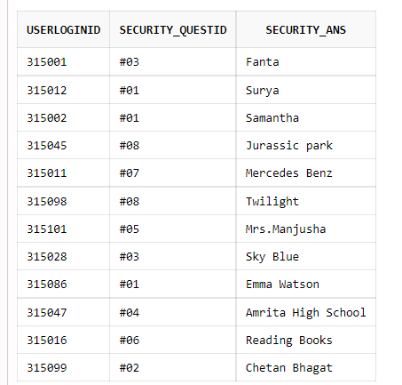

TABLE 6:

Create Table SECURITY_QUEST (Security_QuestID varchar(3) PRIMARY KEY, Security_Questions varchar(50));

Insert into SECURITY_QUEST values('#01','Your Faviourite Actor/Actress');

Insert into SECURITY_QUEST values('#02','Your Faviourite Book Author');

Insert into SECURITY_QUEST values('#03','Your Faviourite Colour');

Insert into SECURITY_QUEST values('#04','Your Faviourite School that you studied');

Insert into SECURITY_QUEST values('#05','Your Faviourite Teacher from childhood');

Insert into SECURITY_QUEST values('#06','Your Hobby');

Insert into SECURITY_QUEST values('#07','Your Faviourite Car Brand');

Insert into SECURITY_QUEST values('#08','Your Faviourite Movie');

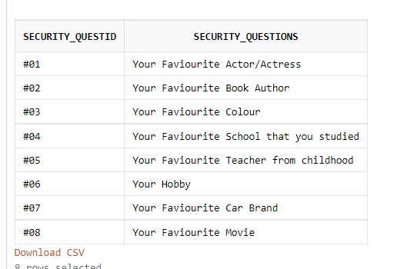

TABLE 7:

Create table TRANSACTION (TransactionID varchar(15) PRIMARY KEY, TransactionDate timestamp, TransactionType varchar2(20), TransactionAmount float, NewBalance float,

WithdrawalCount int, DepositCount int, OldBalance float);

Insert into TRANSACTION values('2101001831501',timestamp '2019-01-21 11:30:19','Deposit','25000','28500',0,1,3500);

Insert into TRANSACTION values('2101001800501',timestamp '2020-04-12 09:30:19','Withdraw','3000','25500',1,1,28500);

Insert into TRANSACTION values('2101001888801',timestamp '2019-06-13 11:55:20','Withdraw','2000','23500',2,1,25000);

Insert into TRANSACTION values('2101001845801',timestamp '2019-08-14 10:30:15','Withdraw','2000','22500',3,1,23500);

Insert into TRANSACTION values('2101001888802',timestamp '2020-02-24 12:33:16','Deposit','5000','27500',3,2,22500);

Insert into TRANSACTION values('2101001888803',timestamp '2019-04-25 17:21:12','Deposit','3000','30500',3,3,27500);

Insert into TRANSACTION values('2101001848901',timestamp '2020-05-26 18:15:13','Deposit','10000','40500',3,4,30500);

Insert into TRANSACTION values('2101001848902',timestamp '2019-09-08 10:16:24','Deposit','15500','56000',3,5,40500);

Insert into TRANSACTION values('2101001862901',timestamp '2021-07-02 04:12:32','Deposit','20000','76000',3,6,56000);

Insert into TRANSACTION values('2101001831502',timestamp '2019-06-15 03:07:45','Deposit','24000','100000',3,7,76000);

Insert into TRANSACTION values('2101001888804',timestamp '2018-04-06 00:08:56','Withdraw','30000','70000',4,7,100000);

Insert into TRANSACTION values('2101001850701',timestamp '2020-05-08 05:09:06','Withdraw','2000','68000',5,7,70000);

Insert into TRANSACTION values('2101001811101',timestamp '2019-03-07 15:30:23','Withdraw','10000','58000',6,7,68000);

Insert into TRANSACTION values('2101001856701',timestamp '2019-03-03 19:02:04','Deposit','14000','72000',6,8,5800);

Insert into TRANSACTION values('2101001811102',timestamp '2020-03-02 20:15:06','Deposit','18000','90000',6,9,72000);

Insert into TRANSACTION values('2101001811103',timestamp '2020-08-01 23:22:08','Withdraw','40000','50000',7,9,90000);

Insert into TRANSACTION values('2101001854101',timestamp '2021-09-05 03:24:10','Deposit','3000','53000',7,10,50000);

Insert into TRANSACTION values('2101001900701',timestamp '2019-05-16 07:48:12','Withdraw','20000','33000',8,10,53000);

Insert into TRANSACTION values('2101001812501',timestamp '2020-07-18 09:58:14','Deposit','100000','133000',8,11,33000);

Insert into TRANSACTION values('2101001812502',timestamp '2019-06-20 10:33:23','Withdraw','50000','50000',9,11,133000);

Insert into TRANSACTION values('2101001845802',timestamp '2020-04-21 11:36:25','Deposit','30000','80000',9,12,50000);

Insert into TRANSACTION values('2101001860601',timestamp '2019-04-22 12:39:28','Deposit','20000','100000',9,13,80000);

Insert into TRANSACTION values('2101001830001',timestamp '2019-08-24 13:44:19','Deposit','30000','130000',9,14,100000);

Insert into TRANSACTION values('2101001829001',timestamp '2019-09-26 05:46:36','Withdraw','15000','115000',10,14,130000);

Insert into TRANSACTION values('2101001826101',timestamp '2021-04-28 04:48:42','Withdraw','10000','105000',11,14,115000);

Insert into TRANSACTION values('2101001865401',timestamp '2019-01-18 21:28:45','Deposit','20000','125000',11,15,105000);

Insert into TRANSACTION values('2101001865402',timestamp '2021-05-19 22:18:56','Deposit','5000','130000',11,16,125000);

Insert into TRANSACTION values('2101001800801',timestamp '2020-01-21 04:28:26','Withdraw','10000','120000',12,16,130000);

Insert into TRANSACTION values('2101001811201',timestamp '2020-05-20 09:06:32','Withdraw','15000','105000',13,16,105000);

Insert into TRANSACTION values('2101001800802',timestamp '2020-01-16 11:09:35','Withdraw','3000','102000',14,16,105000);

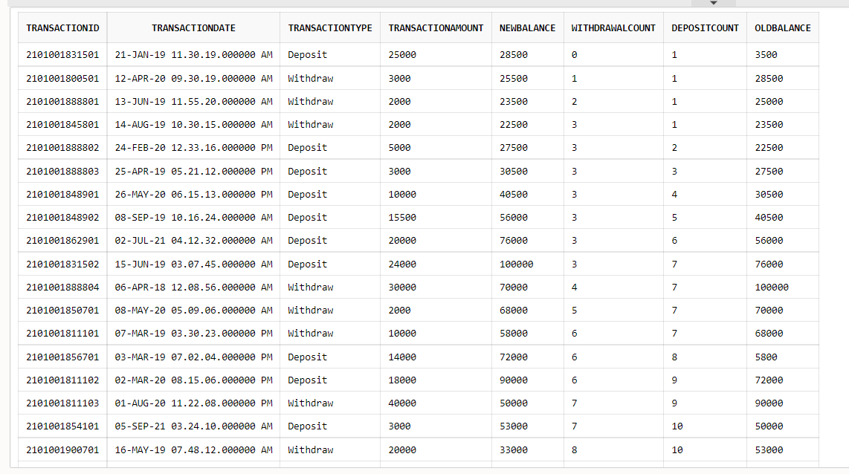

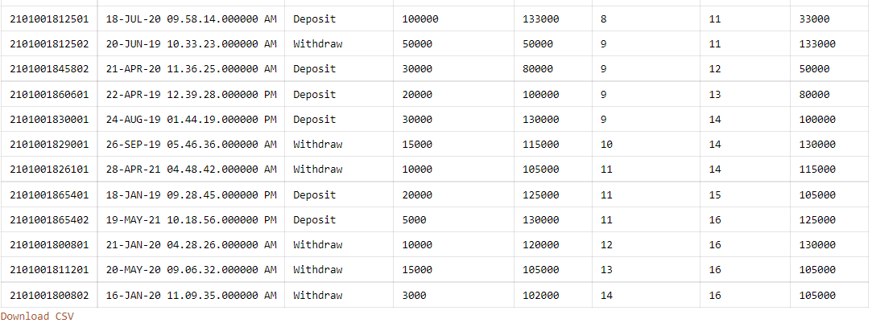

TABLE 8:

Create Table State_city(City varchar2(20),State varchar2(20));

Insert into State_city values('GPO,Chennai','Tamil Nadu');

Insert into State_city values('Anna Road,Chennai','Tamil Nadu');

Insert into State_city values('Saidapet,Chennai','Tamil Nadu');

Insert into State_city values('Adyar,Chennai','Tamil Nadu');

Insert into State_city values('Sowcarpet,Chennai','Tamil Nadu');

Insert into State_city values('Perambur,Chennai','Tamil Nadu');

Insert into State_city values('Koyambedu,Chennai','Tamil Nadu');

Insert into State_city values('Kotturpuram,Chennai','Tamil Nadu');

Insert into State_city values('Thiruvallur','Tamil Nadu');

Insert into State_city values('Theni','Tamil Nadu');

Insert into State_city values('Nungambakkam,Chennai','Tamil Nadu');

Insert into State_city values('Ariyalur,Trichy','Tamil Nadu');

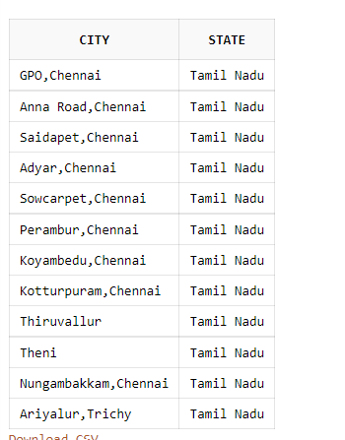

TABLE 9:

Create table Zip (Zip_code int, City varchar2(20));

Insert into Zip values(625543,'Theni');

Insert into Zip values(600001,'GPO,Chennai');

Insert into Zip values(600002,'Anna Road,Chennai');

Insert into Zip values(621704,'Ariyalur,Trichy');

Insert into Zip values(600107,'Koyambedu,Chennai');

Insert into Zip values(600034,'Nungambakkam,Chennai');

Insert into Zip values(600015,'Saidapet,Chennai');

Insert into Zip values(600079,'Sowcarpet,Chennai');

Insert into Zip values(600023,'Perambur,Chennai');

Insert into Zip values(600087,'Thiruvallur');

Insert into Zip values(600085,'Kotturpuram,Chennai');

Insert into Zip values(600020,'Adyar,Chennai');

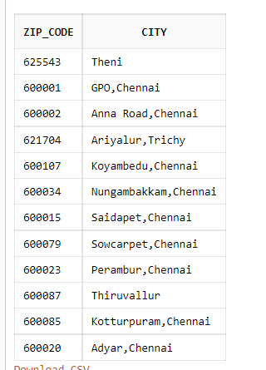

TABLE 10:

Create table LOANTYPE (Loan_Type varchar2(20) PRIMARY KEY, InterestRate float);

Insert into LOANTYPE values('Gold Loan',0.5);

Insert into LOANTYPE values('Housing Loan',6.7);

Insert into LOANTYPE values('Personal Loan',3.8);

Insert into LOANTYPE values('Vehicle Loan',7.25);

Insert into LOANTYPE values('Education',1.2);

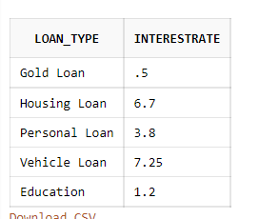

TABLE 11:

Create table LOAN_DETAILS (LoanNumber int PRIMARY KEY, LoanAmount float, LoanApprovalDate date, Loan_Type varchar2(20)) ;

Insert into LOAN_DETAILS values(145, 90000, date '2021-09-01','Gold Loan');

Insert into LOAN_DETAILS values(166, 500000, date '2020-08-16','Home Loan');

Insert into LOAN_DETAILS values(116, 70999, date '2020-05-29','Gold Loan');

Insert into LOAN_DETAILS values(118, 150000, date '2021-09-23','Educational Loan');

Insert into LOAN_DETAILS values(365, 100000, date '2021-03-02','Personal Loan');

Insert into LOAN_DETAILS values(256, 250000, date '2021-07-06','Vehicle Loan');

Insert into LOAN_DETAILS values(456, 55000, date '2020-08-12','Personal Loan');

Insert into LOAN_DETAILS values(236, 89000, date '2020-02-17','Vehicle Loan');

Insert into LOAN_DETAILS values(189, 600000, date '2020-01-22','Home Loan');

Insert into LOAN_DETAILS values(555, 130000, date '2021-04-15','Educational Loan');

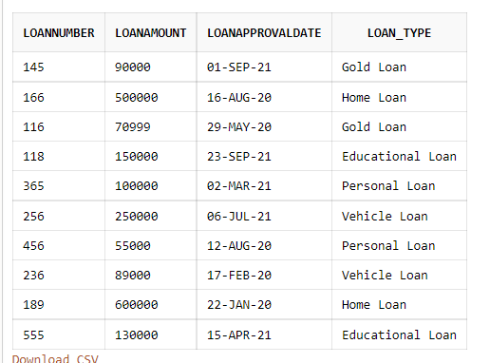

TABLE 12:

Create table CARD_DETAILS (CardNumber varchar(16) PRIMARY KEY, CardHolder varchar2(20), CardType varchar(20), CCV number(3), ExpirtDate date) ;

INSERT into CARD_DETAILS values('9987654309280098','Nick Santa','VISA',645, date '2023-06-17');

INSERT into CARD_DETAILS values('7494654843154125','Andrew Donald','MASTERCARD',792, date '2024-05-14');

INSERT into CARD_DETAILS values('6894651684546846','Eric C','DEBIT',413, date '2025-11-22');

INSERT into CARD_DETAILS values('2354513546812851','Sandra Joe','CREDIT',135, date '2023-12-11');

INSERT into CARD_DETAILS values('8466546841316412','Carol Amy','DEBIT',665, date '2022-11-09');

INSERT into CARD_DETAILS values('4846516845165845','Donna Kelly','CREDIT',876, date '2026-01-07');

INSERT into CARD_DETAILS values('3484656845684831','Tyler Frank','MASTERCARD',113, date '2025-05-05');

INSERT into CARD_DETAILS values('8465484546875164','Alice Cooper','CREDIT',852, date '2024-07-15');

INSERT into CARD_DETAILS values('7454684154984135','Janny Ann','CREDIT',845, date '2023-05-22');

INSERT into CARD_DETAILS values('5981654681354651','Billy Bruce','DEBIT',796, date '2022-03-18');

INSERT into CARD_DETAILS values('5184656846516846','Carl Terry','MASTERCARD',135, date '2026-08-21');

INSERT into CARD_DETAILS values('1846546841354685','Julie Amber','CREDIT',782, date '2024-09-23');

INSERT into CARD_DETAILS values('2468449846549868','Nick Andrews','MASTERCARD',624, date '2025-09-24');

INSERT into CARD_DETAILS values('5168746538465654','Joffery San','VISA',486, date '2022-06-16');

INSERT into CARD_DETAILS values('3465168465498468','John Luck','MASTERCARD',693, date '2024-05-18');

INSERT into CARD_DETAILS values('6465468415498413','Rikky Pant','DEBIT',741, date '2026-04-08');

INSERT into CARD_DETAILS values('4651654313543232','Nancy Drew','CREDIT',153, date '2025-03-09');

INSERT into CARD_DETAILS values('8768454684351684','Ronnie Lodge','DEBIT',482, date '2024-02-07');

INSERT into CARD_DETAILS values('6684654156455465','Martha Jose','CREDIT',635, date '2025-01-03');

INSERT into CARD_DETAILS values('8465465465354315','Rose Michael','VISA',979, date '2023-12-04');

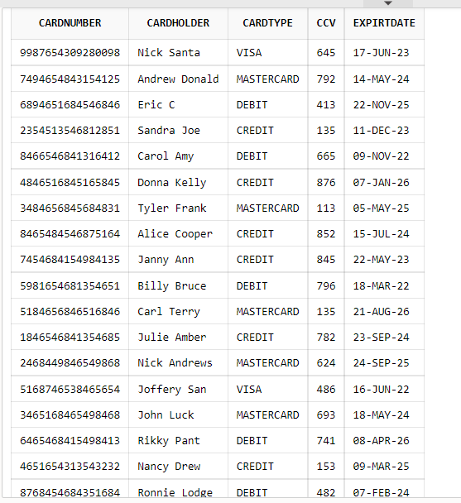

TABLE 13:

Create table BILL_PAYMENTS (BillPayment_no varchar(20) PRIMARY KEY, PaymentType varchar(30),PaymentConfirmation varchar(15), PaymentAmount float);

Insert into BILL_PAYMENTS values('#ORID08267e256','Net banking','Confirmed',2500);

Insert into BILL_PAYMENTS values('#ORID08975d234','UPI','Not Confirmed',999);

Insert into BILL_PAYMENTS values('#ORID89652b657','Net banking','Confirmed',3599);

Insert into BILL_PAYMENTS values('#ORID74125t698','Net banking','Not Confirmed',599);

Insert into BILL_PAYMENTS values('#ORID23654j258','Cheque','Not Confirmed',1040);

Insert into BILL_PAYMENTS values('#ORID56456p896','Credit card','Confirmed',259);

Insert into BILL_PAYMENTS values('#ORID71395a569','Net banking','Confirmed',1660);

Insert into BILL_PAYMENTS values('#ORID15968r256','Credit Card','Confirmed',2700);

Insert into BILL_PAYMENTS values('#ORID74265g789','Cheque','Confirmed',2578);

Insert into BILL_PAYMENTS values('#ORID25634k896','UPI','Confirmed',259);

Insert into BILL_PAYMENTS values('#ORID67235u842','Net banking','Confirmed',89);

Insert into BILL_PAYMENTS values('#ORID82148x789','UPI','Confirmed',250);

Insert into BILL_PAYMENTS values('#ORID52525j854','Debit Card','Not Confirmed',2300);

Insert into BILL_PAYMENTS values('#ORID44664m458','Debit Card','Confirmed',4500);

Insert into BILL_PAYMENTS values('#ORID23322o564','UPI','Confirmed',2880);

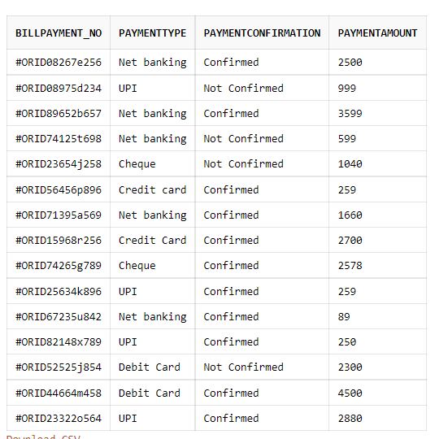

TABLE 14:

Create table FailedTransactionLog (FailedTransaction_errorType varchar(30), FailedTransactionID varchar(15) PRIMARY KEY) ;

Insert into FailedTransactionLog values('Network','2101001831501');

Insert into FailedTransactionLog values('Network','2101001811103');

Insert into FailedTransactionLog values('Network','2101001860601');

Insert into FailedTransactionLog values('Network','2101001865402');

Insert into FailedTransactionLog values('Network','2101001888802');

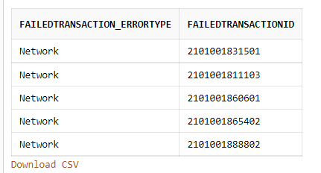

TABLE 15:

Create Table USERLOGINS (UserLoginID int PRIMARY KEY, UserName varchar(20), password varchar(12));

Insert into USERLOGINS values(315001,'NickSanta','abcdefghijkl');

Insert into USERLOGINS values(315101,'CarolAmy','mskxhdnzjsnd');

Insert into USERLOGINS values(315016,'DonnaKelly','abcdebkzdnkx');

Insert into USERLOGINS values(315047,'JuliaAmber','abdkecxjfbd');

Insert into USERLOGINS values(315028,'BillyBruce','iskfjddkzuql');

Insert into USERLOGINS values(315086,'TylerFrank','weguyqoitjkl');

Insert into USERLOGINS values(315098,'AliceCooper','aaypletcuirl');

Insert into USERLOGINS values(315011,'NickAndrews','auielodtyupl');

Insert into USERLOGINS values(315045,'CarlTerry','abcdaiporylo');

Insert into USERLOGINS values(315099,'MarthaJose','ndpoeyuprnzl');

Insert into USERLOGINS values(315002,'RonnieLodge','bamkywkoeudj');

Insert into USERLOGINS values(315012,'JofferySan','pwormxtjsilk');

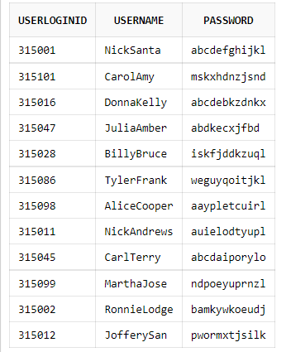

TABLE 16:

Create table Cus_Mobile (Customer_id int, Mobile_no number(10),PRIMARY KEY (Customer_id,Mobile_no));

Insert into Cus_Mobile values(900001,9087673450);

Insert into Cus_Mobile values(900002,9087410987);

Insert into Cus_Mobile values(900023,9087672098);

Insert into Cus_Mobile values(900031,9087436409);

Insert into Cus_Mobile values(900099,9087673412);

Insert into Cus_Mobile values(900035,9087436411);

Insert into Cus_Mobile values(900050,9087671094);

Insert into Cus_Mobile values(900008,9087410456);

Insert into Cus_Mobile values(900011,8803982056);

Insert into Cus_Mobile values(900012,9018409356);

Insert into Cus_Mobile values(900088,9087620856);

Insert into Cus_Mobile values(900076,9087104656);

Insert into Cus_Mobile values(900109,9087620956);

Insert into Cus_Mobile values(900054,9087416756);

Insert into Cus_Mobile values(900004,9081953456);

Insert into Cus_Mobile values(900034,9189436456);

Insert into Cus_Mobile values(900059,9087673107);

Insert into Cus_Mobile values(900019,9087410956);

Insert into Cus_Mobile values(900010,9030073456);

Insert into Cus_Mobile values(900005,9087676456);

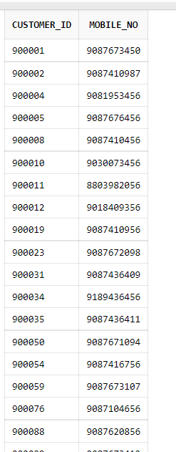

TABLE 17:

Create table Emp_Mob(Emp_id varchar(10), Emp_Mobile number(10),PRIMARY KEY (Emp_id, Emp_Mobile) );

Insert into Emp_Mob values('AMAR0001',7087673450);

Insert into Emp_Mob values('SARA0002',7187410987);

Insert into Emp_Mob values('AMAL0004',7287672098);

Insert into Emp_Mob values('MICH0005',7387436409);

Insert into Emp_Mob values('DANI0007',7487673412);

Insert into Emp_Mob values('JOSH0003',7587436411);

Insert into Emp_Mob values('BETT0009',7687671094);

Insert into Emp_Mob values('SHAR0011',7787410456);

Insert into Emp_Mob values('EMIL0015',7803982056);

Insert into Emp_Mob values('RYAN0010',7918409356);

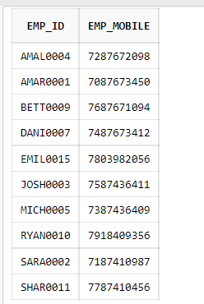

TABLE 18:

Create table Loan_num(Customer_id int, LoanNumber int,PRIMARY KEY (Customer_id,LoanNumber));

Insert into Loan_num values(900001,145);

Insert into Loan_num values(900001,166);

Insert into Loan_num values(900002,116);

Insert into Loan_num values(900023,118);

Insert into Loan_num values(900099,365);

Insert into Loan_num values(900010,256);

Insert into Loan_num values(900050,189);

Insert into Loan_num values(900010,555);

Insert into Loan_num values(900088,236);

Insert into Loan_num values(900050,456);

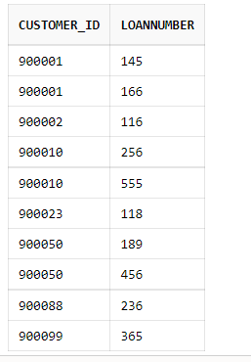

TABLE 19:

Create table Transact (AccountID varchar(20), TransactionID varchar(15), PRIMARY KEY (AccountID,TransactionID));

Insert into Transact values('13520010018315','2101001831501');

Insert into Transact values('13520010018315','2101001831502');

Insert into Transact values('13520010018005','2101001800501');

Insert into Transact values('13520010018888','2101001888801');

Insert into Transact values('13520010018888','2101001888802');

Insert into Transact values('13520010018888','2101001888803');

Insert into Transact values('13520010018888','2101001888804');

Insert into Transact values('13520010018458','2101001845801');

Insert into Transact values('13520010018458','2101001845802');

Insert into Transact values('13520010018489','2101001848901');

Insert into Transact values('13520010018489','2101001848902');

Insert into Transact values('13520010018629','2101001862901');

Insert into Transact values('13520010018507','2101001850701');

Insert into Transact values('13520010018111','2101001811103');

Insert into Transact values('13520010018111','2101001811101');

Insert into Transact values('13520010018111','2101001811102');

Insert into Transact values('13520010018567','2101001856701');

Insert into Transact values('13520010018541','2101001854101');

Insert into Transact values('13520010018007','2101001800701');

Insert into Transact values('13520010018125','2101001812501');

Insert into Transact values('13520010018125','2101001812502');

Insert into Transact values('13520010018606','2101001860601');

Insert into Transact values('13520010018300','2101001830001');

Insert into Transact values('13520010018290','2101001829001');

Insert into Transact values('13520010018261','2101001826101');

Insert into Transact values('13520010018654','2101001865401');

Insert into Transact values('13520010018654','2101001865402');

Insert into Transact values('13520010018008','2101001800802');

Insert into Transact values('13520010018112','2101001811201');

Insert into Transact values('13520010018008','2101001800801');

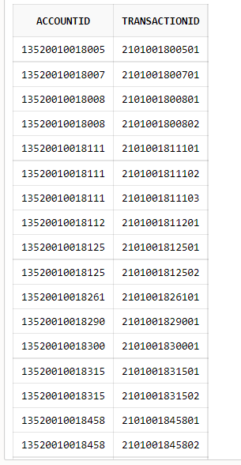

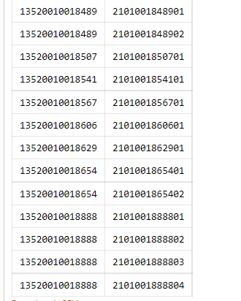

TABLE 20:

Create table Bill (AccountID varchar(20), Billpayment_no varchar(20), PRIMARY KEY (AccountID,Billpayment_no));

Insert into Bill values('13520010018315','#ORID08267e256');

Insert into Bill values('13520010018007','#ORID08975d234');

Insert into Bill values('13520010018606','#ORID89652b657');

Insert into Bill values('13520010018261','#ORID74125t698');

Insert into Bill values('13520010018007','#ORID23654j258');

Insert into Bill values('13520010018300','#ORID56456p896');

Insert into Bill values('13520010018629','#ORID71395a569');

Insert into Bill values('13520010018606','#ORID74265g789');

Insert into Bill values('13520010018315','#ORID25634k896');

Insert into Bill values('13520010018606','#ORID67235u842');

Insert into Bill values('13520010018567','#ORID15968r256');

Insert into Bill values('13520010018112','#ORID82148x789');

Insert into Bill values('13520010018111','#ORID52525j854');

Insert into Bill values('13520010018458','#ORID44664m458');

Insert into Bill values('13520010018888','#ORID23322o564');

select * from Bill;

